Flehmen | Pricked ears  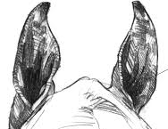 | Kicking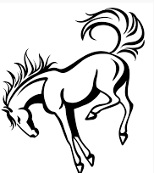 | Rolling in the dirt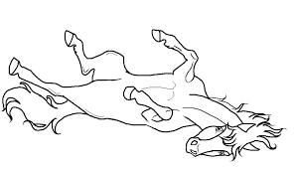
Sniffing the ground | Snort | FREE | Squeal!
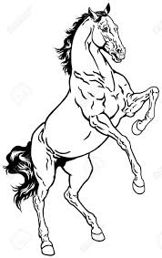 rearing | Whinny | One horse chasing another | Swishing tail
Pinned ears | 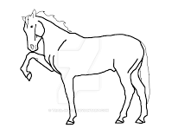  Pawing | Sneeze | 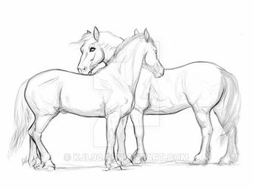  Mutual grooming

One horse chasing another | Pricked ears | Mutual Grooming | Rolling in the dirt
Sniffing the ground | Sneeze | raised tail | Snort
rearing | FREE | Flehmen | Swishing tail
Pinned ears | Pawing | whinny | Kicking  (one or both back feet)

One horse chasing another | Pricked ears | Mutual Grooming | Pinned ears
SNORT | Sneeze | FREE | Sniffing the  ground
rearing | Raised tail | Flehmen | Swishing tail
Rolling in the dirt | Pawing | whinny | Kicking  (one or both back feet)

